

Students will need to create an account with Adobe (unless you already have one) in order to access the Adobe suite at the college – instructions are included below. They will need to use a personal email address to create this.

Please note:

* Creating an Adobe account is free.
* The software will only be accessible when logged into a UAL networked computer
* The same account can be used outside of the University, but software will only be accessible through a personal paid subscription that students will need to set up independently
* Students can still create an account on the day but doing this beforehand will save time and avoid delays to the start of the class.
* If students already have an Adobe ID/ subscription they can use this on your short course rather than setting up a new account.

To create an account students will need to go to the [Adobe site](https://helpx.adobe.com/uk/manage-account/using/create-update-adobe-id.html).

**Adobe Stock Access**

Adobe Stock assets are available at <https://stock.adobe.com/>

Staff have unlimited Adobe Stock downloads.

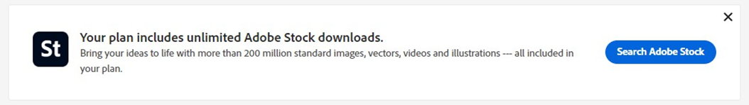

UALSC Students (users with personal accounts) have very limited access to Adobe Stock assets. After downloading a few photos, the user will be prompted to sign up for a Stock subscription. This also happens when the ‘Free’ option is selected.

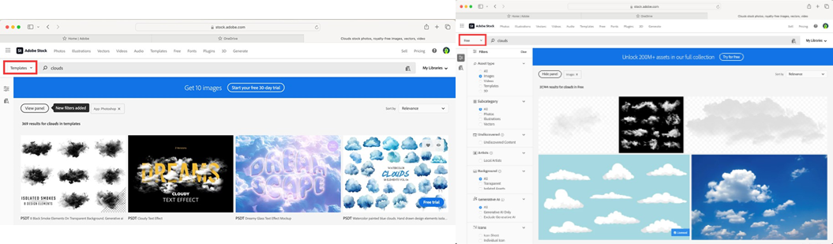

The user then needs to subscribe to Adobe Stock to be able to download Stock assets.



See the link below for more information on licensing: <https://stock.adobe.com/uk/license-terms?msockid=2ece8b33711364092f4c9e2670066566>



**Adobe Font Access**

There are no noticeable differences between access to Adobe Fonts via UAL staff account regarding access and the choice of fonts.

In order to add fonts to the Adobe apps using Adobe Fonts page, the user needs to go to: <https://fonts.adobe.com/>

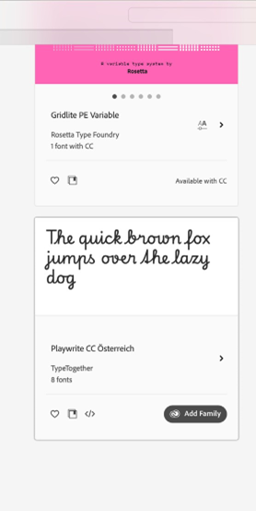 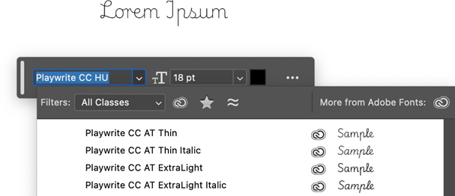

Find a font they want to add. Go back to the Adobe app e.g. Photoshop.

Select ‘Add Family’ Find the new font.

If the user has difficulty finding the font in the software, they can check the display name of the font at the font’s page. It is easy to find for any competent design tutor.

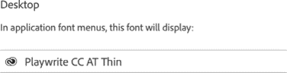

Below is the link to Fonts licensing <https://helpx.adobe.com/uk/fonts/using/add-font-licenses.html>

***NB:*** *the above only applies to UAL devices and does not cover any use on personal devices or when working offsite unless you are a member of staff or are a student with a personal Adobe subscription. Downloading of fonts outside of the Adobe platform is not covered, Google fonts for example would require admin rights for installation and possibly a license and should not be encouraged.*

