Padlet Quick Guide

Go to: artslondon.padlet.org.
Click ‘Log in with Microsoft’ and log in with your UAL username and password.
Click on “Make”
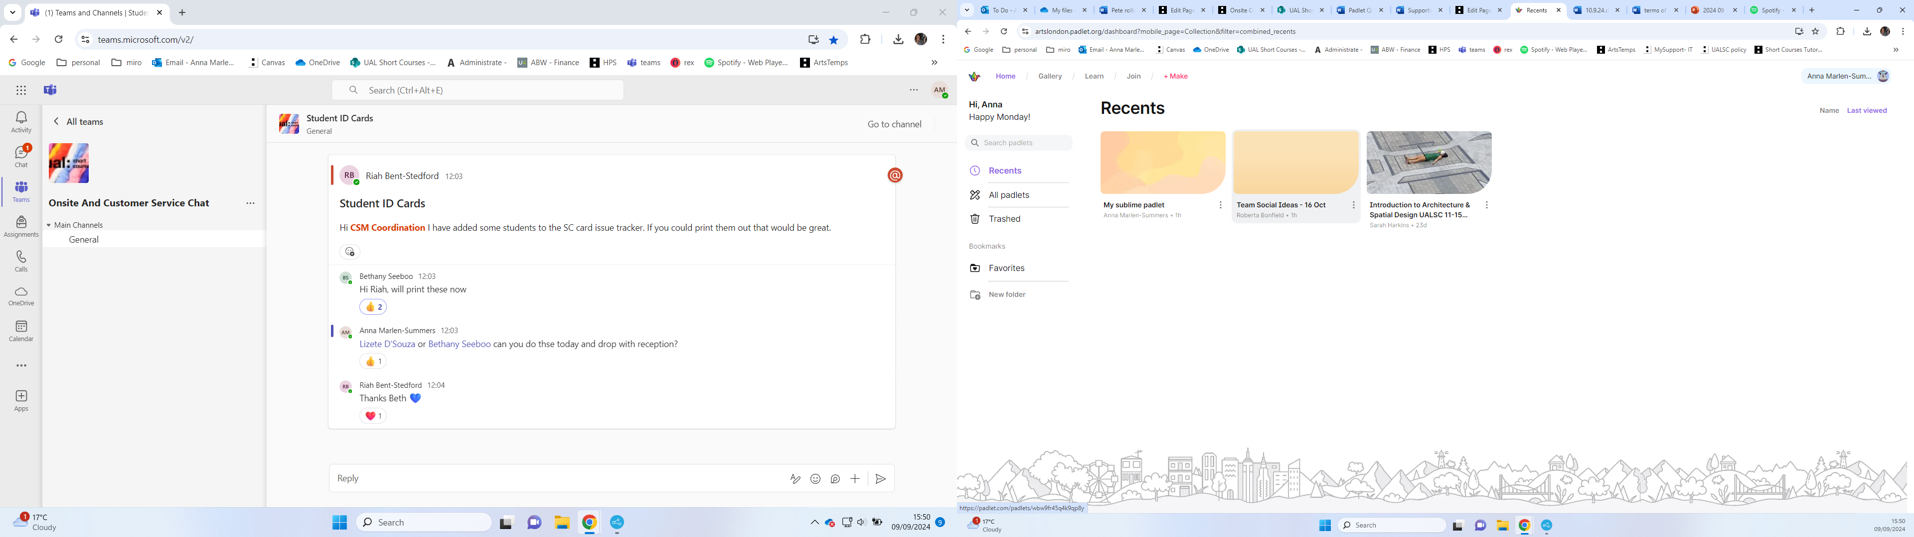

Click on “Blank board”
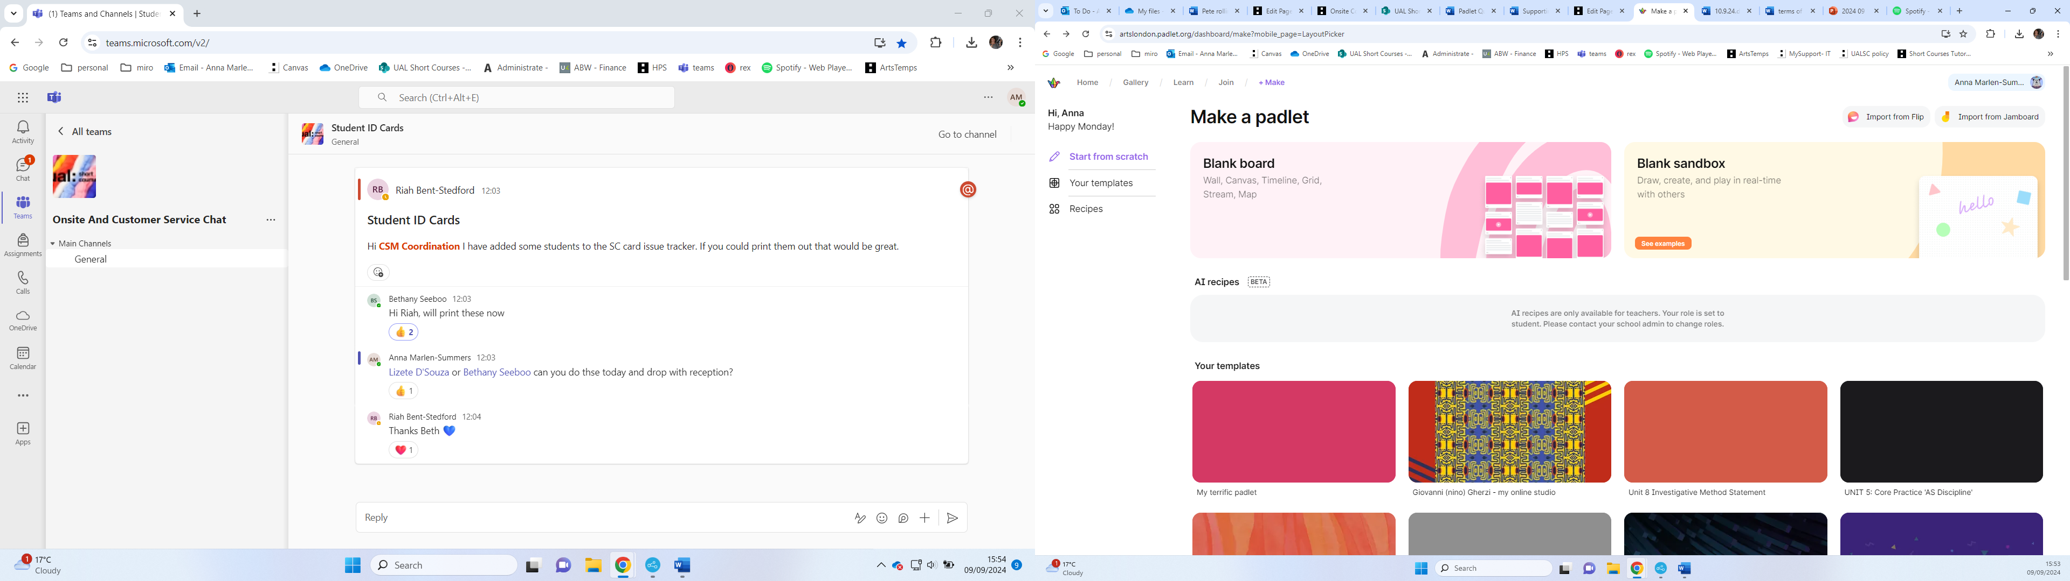

Click on the “share” Icon
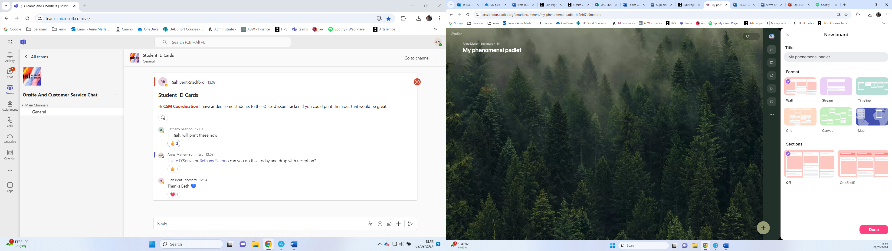

Click on “share “tab, and then “get QR code”
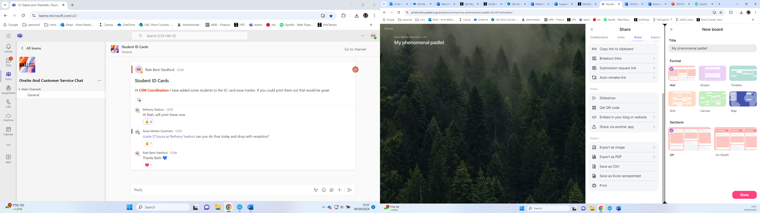Learner can then scan the QR code and access the Padlet.

Double click in the body of the Padlet page and a tile will appear:
Type in or link the information you want the learners to access. Click publish
